**ECO 304L Exam 2 Spring 2024**

**Versions: AC**

**Last Name: __________________**

**First Name: __________________**

**UT ID: __________________**

**Directions:** There are 40 questions on this exam. Each question is worth the same (1 point). You also **MUST SKIP 3** questions, which are automatically counted correct. For each multiple-choice question, select the best response. For each short answer question, you can earn 1/2 credit if your answer is incorrect, but you explain your reasoning/show your work. This is a closed book, closed notes exam. You may use a physical calculator but may not use a cell phone or any other electronic device during the exam. Make sure you write your full name and UT ID above. Hand in your exam and show your student ID to the TA when turning in your exam. Good luck!

**\*\*\*Write the word SKIP next to three questions\*\*\***

**Multiple-Choice Answers: Short Answers:**

**1. ________ 17. ________ 33. _____%**

**2. ________ 18. ________ 34. _____%**

**3. ________ 19. ________ 35. Circle one choice**

**4. ________ 20. ________** shift out

**5. ________ 21. ________** shift in

**6. ________ 22. ________** move up along

**7. ________ 23. ________** move down along

**8. ________ 24. ________ 36. _______________**

**9. ________ 25. ________ 37.** Price: **__________**

**10. ________ 26. ________** Output: **__________**

**11. ________ 27. ________** Unemployment**: __________**

**12. ________ 28. ________ 38. __________**

**13. ________ 29. ________ 39. Circle the curve & shift direction**

**14. ________ 30. ________** SRAS/LRAS/AD & shiftsLEFT/RIGHT

**15. ________ 31. ________ 40. __________**

**16. ________ 32. ________**

**For Graders**

**Correct SA: ____ + Partial Credit: ____ x 1/2 ____ = Total SA Points: ____**

**TOTAL POINTS: MC: _____ + SA: _____ + 3 SKIPS = /40**

**1. Nominal gross domestic product (GDP) growth is equal to real GDP growth minus the inflation rate.**

A) True

B) False

**2. Why do institutions, such as private property rights, promote economic growth?**

A) Private property rights guarantee that the economy is stable in the short run, which encourages investment.

B) Private property rights guarantee that everyone will have equal amounts of property.

C) Private property rights create an incentive to maximize the value of one’s property, which is not true when property is collectively owned.

D) Private property rights are not established by governments but rather by private individuals.

**3. If an economy experiences economic growth, does that mean that everyone in that economy is better off?**

A) Yes, but only if there is little immigration during that time period.

B) No, economic growth is not correlated with standard of living.

C) Yes, but only if nominal gross domestic product (GDP) increases.

D) No, it means that, on average, people are better off.

**4. When computing economic growth, changes in nominal gross domestic product (GDP) must be adjusted to reflect changes in the price level because:**

A) an increase in prices will increase nominal GDP without any actual economic growth.

B) prices are nearly impossible to measure by government economists.

C) an increase in prices will decrease nominal GDP without any actual economic growth.

D) changes in prices are primarily determined by the government.

**5. Average world income rapidly began to rise during the Industrial Revolution because ________ outpaced ________.**

A) population growth; life expectancy

B) life expectancy; mortality rates

C) school enrollment rates; technological progress

D) technological progress; population growth

**6. In a population, the size of the labor force shrinks but a greater percentage of the labor force has a college degree. We can expect the human capital input to**

A) increase or decrease depending on which change has a larger impact.

B) increase.

C) decrease.

D) first increase and then decrease.

**7. Consider the following graph. According to new growth theory, what would cause a downward shift of the production function?**

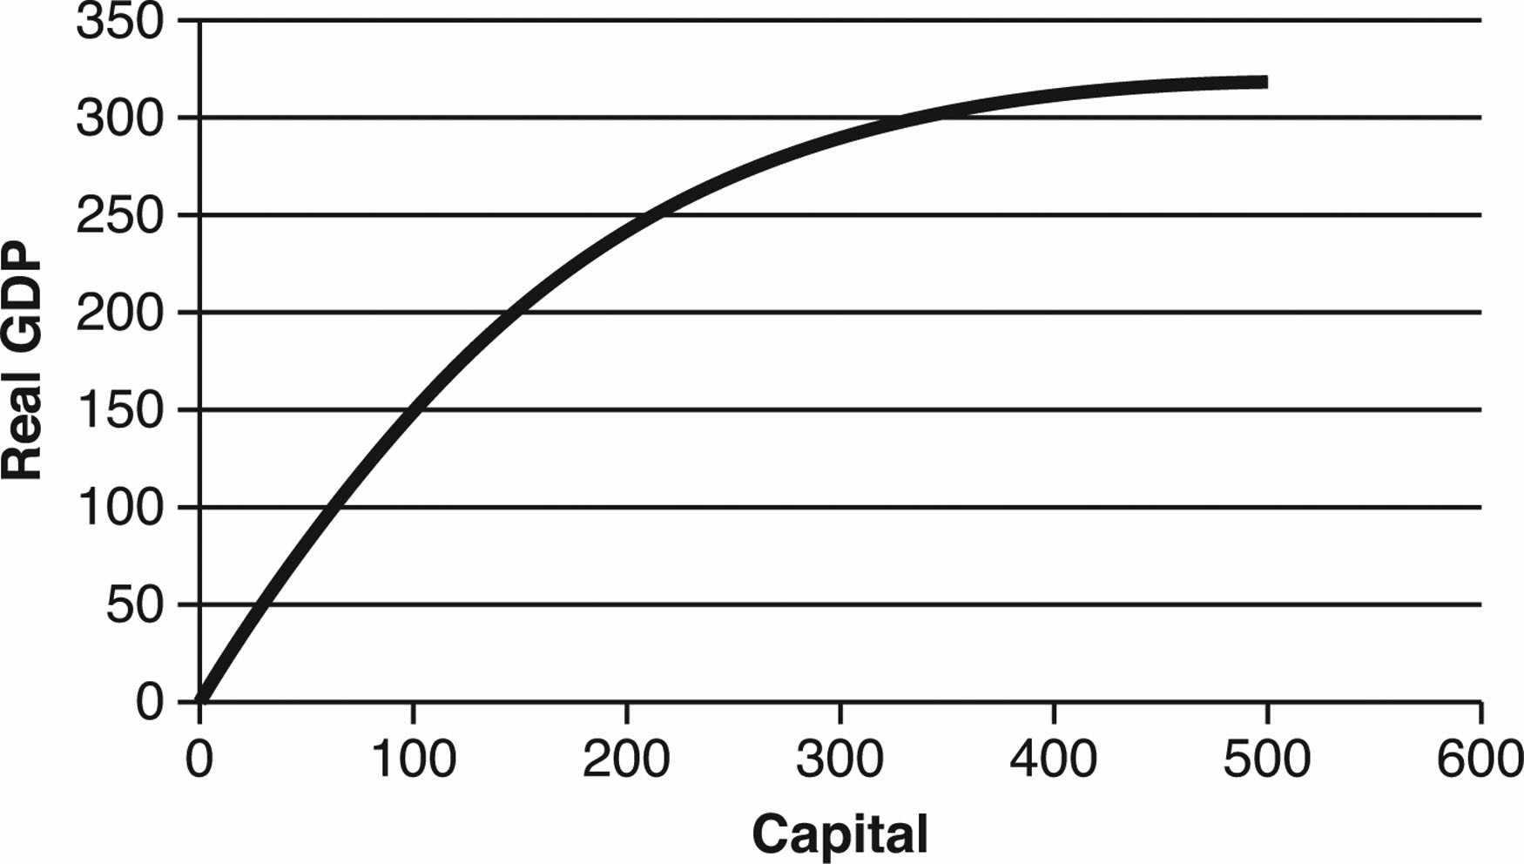

A) A decrease in capital.

B) A decrease in investment.

C) A war that creates a large amount of political instability.

D) More than one answer is correct.

***Consider the data in the following table.***

|  |  |  |
| --- | --- | --- |
| Year | **Growth Rate of Real Investment** | **Growth Rate of Real GDP** |
| 1 | 0% | 2% |
| 2 | –2% | –3% |
| 3 | 3% | 5% |
| 4 | –1% | 0% |
| 5 | 1% | 1% |

**8. Does the data match the experience of a developed country like the United States?**

A) Yes, because the two growth rates are positively correlated.

B) No, because the two growth rates should be positively correlated.

C) Yes, because the two growth rates are negatively correlated.

D) No, because the two growth rates should be negatively correlated.

**9. If Country X has a higher growth rate of real investment than Country Y, then it must have a higher level of real gross domestic product (GDP) than Country Y.**

A) True.

B) False.

**10. Suppose the level of capital in the economy is 7,000 units, the depreciation rate is 10%, and investment is equal to 350 units. In this case:**

A) the economy is in a steady state.

B) the capital stock will increase.

C) the capital stock will decrease.

D) the level of output will decrease.

**11. In 1950, residents in Liberia were wealthier than those in Taiwan. Today, per capita gross domestic product (GDP) in Taiwan is more than twenty times that of Liberia. How would private property rights help explain why Taiwan is now so much wealthier than Liberia?**

A) The government prevents people from exploiting others for their property in Liberia.

B) In Liberia, all property is owned by the state.

C) Taxes in Liberia are so high that people have no incentive to improve the value of their property.

D) With a well-developed system of property rights in Taiwan, people have very strong incentives to improve the value of their assets.

**12. Suppose a major hurricane hits the eastern coast of Florida and destroys significant amounts of physical capital. Considering the production function that illustrates the relationship between real gross domestic product (GDP) and capital, in the long run, you would expect that:**

A) the production function will have shifted downward.

B) there has been no effect on the production function and real gross domestic product (GDP) returns to the steady state level.

C) the production function will shift back above its original position after having shifted downward in the short run.

D) there has been a permanent downward movement along the production function.

**13. Suppose a decrease in the price level increases the value of real wealth, which then causes an increase in consumption but no change in saving. In this case, there is:**

A) a wealth effect but no interest rate effect.

B) both an interest rate effect and a wealth effect.

C) no wealth effect.

D) an interest rate effect but no wealth effect.

**14. An increase in aggregate demand (AD) can be harmful because:**

A) firms have sticky input prices and earn less profit.

B) workers with sticky wages are paying more for goods and services.

C) unemployment rises.

D) output has always risen above the full-employment level.

***Suppose that you have the following information about the economy, where all figures are in millions of dollars:***

Full-employment output = $2,000

Consumption spending = $1,200

Investment spending = $400

Government spending = $500

Net exports = –$200

**15. Because short-run output is ________ full-employment output, in the long run, we would expect the price level to ________.**

A)less than; rise

B) greater than; rise

C) less than; fall

D) greater than; fall

**16. If there is a shift in the long-run aggregate supply (LRAS) curve, the short-run aggregate supply (SRAS) curve also shifts.**

A) True.

B) False.

**17. Suppose a crop disease wipes out a large portion of one country’s agricultural sector. The affected crop is permanently lost. In the long run, the price level will ________ as ________.**

A) increase; aggregate supply (AS) decreases in the short-run but increases in the long run

B) increase; both long-run (LRAS) and short-run aggregate supply (SRAS) decrease

C) decrease; LRAS decreases

D) remain unchanged; LRAS decreases

**18. Which of the following causes a decrease in short-run aggregate supply (SRAS)?**

A) The price level decreases.

B) The price level increases.

C) Firms agree to wage increases.

D) Workers agree to wage cuts.

**19. Classical economists believe government intervention in the economy is necessary because prices are sticky and prevent the economy from moving toward full employment.**

A) True.

B) False.

**Refer to the following graph to answer the question below.**

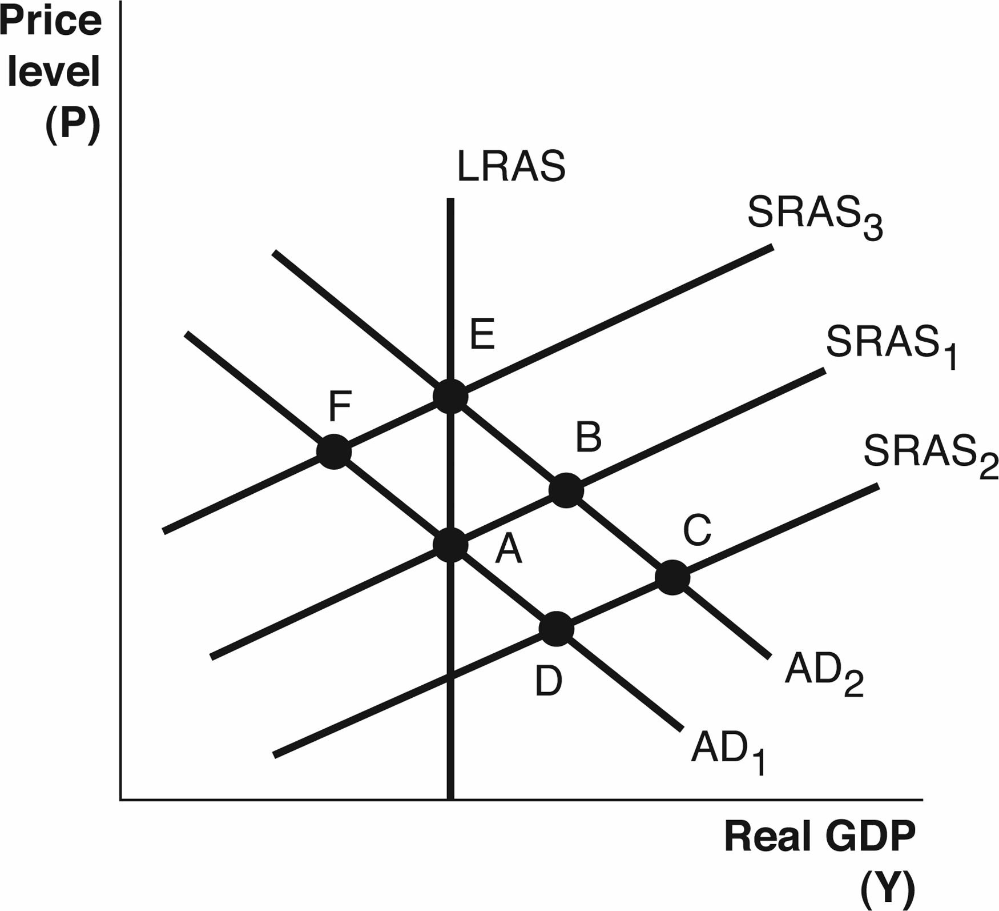

**20. If the economy is at Point F, then, in the long run, we can expect:**

A) the price level to increase and output to increase.

B) the long-run aggregate supply (LRAS) curve to shift to the left.

C) the price level to decrease and output to increase.

D) aggregate demand to increase.

**21. When the government raised taxes at the beginning of the Great Depression, it caused aggregate demand to decrease because:**

A) it caused the stock market to crash, which reduced household wealth.

B) household disposable income decreased, causing consumer spending to decrease.

C) it caused high levels of inflation, which reduced the real value of household income.

D) barriers to international trade decreased at the same time.

**22. Which of the following best summarizes the main causes of the Great Recession?**

A) Oil-producing countries deliberately raised the price of petroleum, leading to inflation and a deep recession.

B) The Federal Reserve raised short-term interest rates very high in an effort to decrease inflation, which also drove the economy into a recession.

C) The stock market collapsed following the end of a bubble in technology stock prices, which caused a decrease in investment spending and a recession.

D) The collapse of housing prices led to decreased wealth and significant problems in the financial markets, as well as a decrease in expected income and a stock market collapse.

**23. Keynesian economists stress the importance of aggregate ________ and generally believe the economy ________ to reach full-employment equilibrium.**

A) demand; needs help

B) supply and demand; needs help

C) supply; needs help

D) supply; does not need help

**24. One difference between the Great Recession and the Great Depression is that:**

A) unemployment was far higher during the Great Recession.

B) very few banks failed during the Great Depression, but many failed during the Great Recession.

C) the U.S. government reduced the money supply during the Great Recession but raised it during the Great Depression.

D) there was significant deflation during the Great Depression and not during the Great Recession.

**25. When financial markets went into a crisis during the Great Recession, it caused long-run aggregate supply to decrease because:**

A) there was a decrease in the level of technology.

B) there were new regulations limiting the number of loans that could be made.

C) the U.S. population and labor force declined abruptly.

D) infrastructure began to fail across the country.

**26. Some people have suggested that social insurance benefits should be indexed to the consumer price index (CPI) instead of the average wage index. What would be an objection to this proposal?**

A) It would be unfair to people who have saved for retirement.

B) It would discourage people from saving for retirement on their own.

C) In recent years, the CPI has risen faster than the average wage index.

D) It does not keep the number of retirees from growing.

**27. Why do Social Security and Medicare pose problems for the federal government budget?**

A) The programs do not cover enough people.

B) The number of retirees is decreasing.

C) The number of sick people is rising too quickly.

D) The worker-to-retiree ratio is decreasing.

**28. To evaluate the size of the federal budget deficit or surplus over time, it would be best to look at the:**

A) absolute size of the budget deficit or surplus.

B) budget deficit or surplus as a percentage of GDP.

C) budget deficit or surplus as a percentage of tax revenues.

D) budget deficit or surplus as a percentage of government spending.

***Use the following graph to answer the next question. This graph shows an economy where aggregate demand has decreased, with no change in either short-run aggregate supply (SRAS) or long-run aggregate supply (LRAS).***

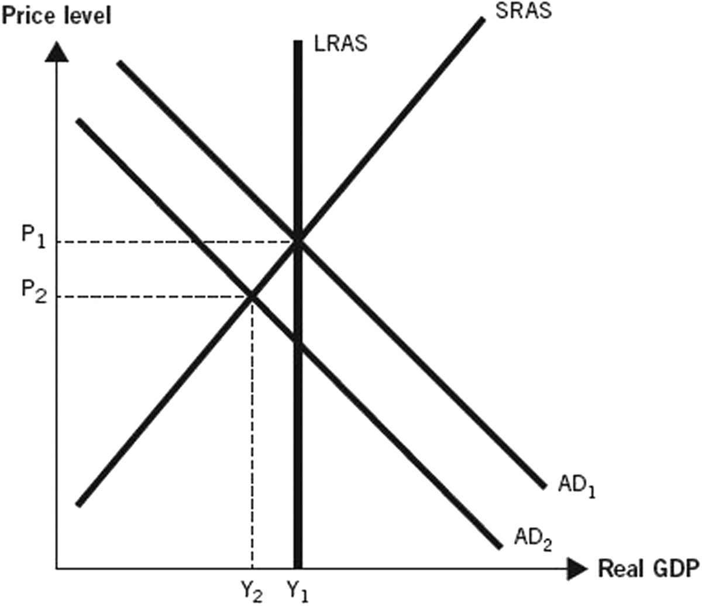

**29. During the Great Depression, the aggregate price level fell by 20% as shown on the graph, suggesting that:**

A) the primary cause of the Great Depression was a decrease in aggregate demand.

B) aggregate demand increased and long-run aggregate supply decreased during the Great Depression.

C) aggregate demand decreased and long-run aggregate supply increased during the Great Depression.

D) the primary cause of the Great Depression was a decrease in long-run aggregate supply.

**30. Why is foreign government ownership of U.S. debt NOT currently a huge concern among many economists?**

A) It could lead to eventual foreign control of our economy and policies, which would encourage economic growth in the future.

B) The United States has a proven track record of negotiating debt-forgiveness deals, so it is unlikely that the debt will have to be paid back.

C) Foreign ownership of U.S. debt drives interest rates up, which is good for savers in the United States.

D) The amount of debt held by foreigners is substantially less than the money the United States owes itself.

**31. The U.S. government should balance the budget annually.**

A) True.

B) False.

**32. Are budget deficits purely the result of partisan ideology in the U.S. government?**

A) Yes, only Democrat-controlled governments have produced deficits.

B) Yes, only Republican-controlled governments have produced deficits.

C) No, the government has historically produced deficits regardless of the partisan makeup of the government.

D) No, the deficits were produced as a result of gridlock in a divided government.

**Enter your answers for the short answer section on the Answer (front) page.**

**33. In 2022, real gross domestic product (GDP) per capita in Bangladesh was roughly $1,100. In 2023, real GDP per capita was $1,188. In this period, prices increased by 2% and population increased by 3%.** **The % change in nominal economic growth for Bangladesh in 2023 is ______.**

**34. A new senator promises to double the real gross domestic product (GDP) by the end of her seven-year term. The average annual economic growth rate would have to be about ________ for this to happen.**

**35. Illustrate what happens when due to an increase in the price level in the U.S., consumers buy less clothing made in the U.S. and more clothing made in the Bahamas.**

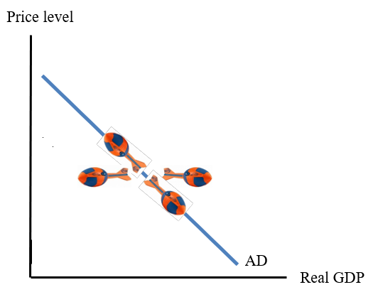

**36.** **In the MrBeast remake of *Squid Game*, each player receives a tin containing a honeycomb imprinted with one of four shapes: a circle, a triangle, a star, or an umbrella. Each participant must extract the shape undamaged from the honeycomb within 10 minutes to remain in the game.**



**One player discovers that licking the honeycomb will melt it and reveal the shape. This could be seen as an improvement in: ____________.**

**37. In 2022, many commodity prices spiked to extremely high levels before coming down again at the end of the year. This temporary event had global effects because these commodities are an important natural resource in the production of goods and services.**

**Assume the economy was in long-run equilibrium before this change.**

**What are the long-term effects of this event on the following variables:**

**Price (P): ____________**

**Output (Y): ____________**

**Unemployment (U): ____________**

**On the front page, write “rise”, “fall” or “no change” for each variable.**

***Use the following table to answer the next question, where GDP = gross domestic product.***

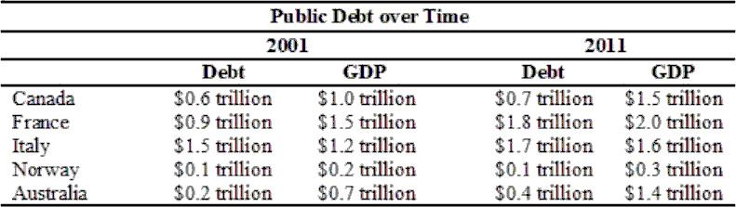

**38. According to the table, the country with the largest decrease in the debt-to-GDP (gross domestic product) ratio over the time period is: ____________**

**39. Assume the economy starts in long-run equilibrium. Suppose now that consumer confidence rises and the economy temporarily expands beyond potential GDP. As part of the adjustment in the long-run, the _______ curve will shift ________ to get the economy back to long-run equilibrium.**

**40. Improvements in how many of the following will shift the production function up?**

* Capital
* Labor
* Natural Resources
* Technology

**Your answer should be a number: 1-4**